LeetCode Program 1342
Link :- https://leetcode.com/problems/number-of-steps-to-reduce-a-number-to-zero/
Successful Submission
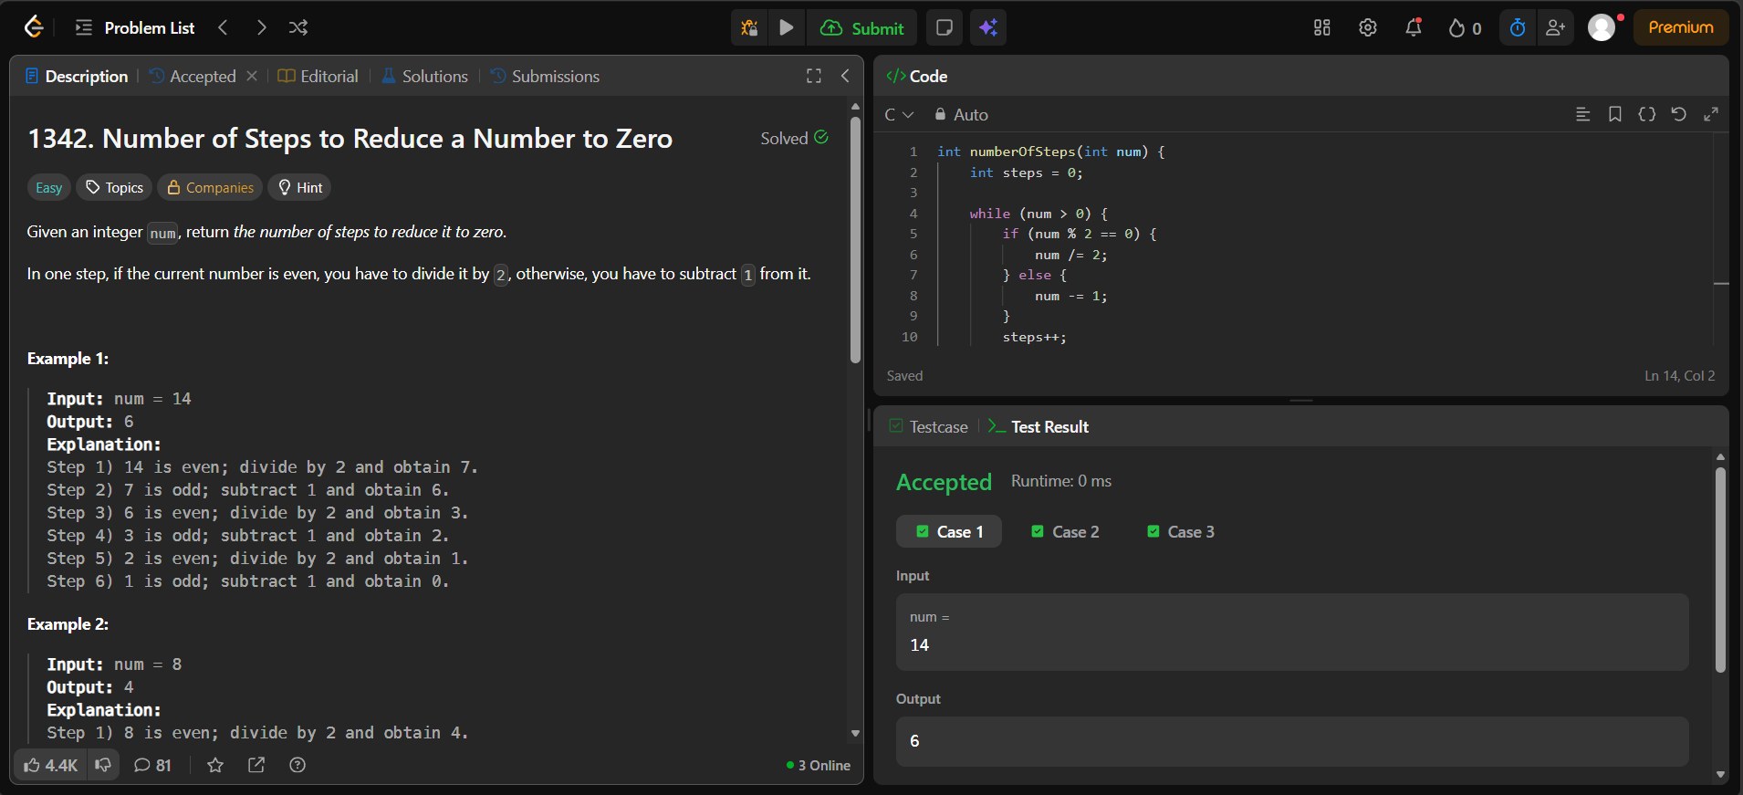
Source Code


